**THE FITNESS RACE - OFFICIAL CONFIRMATION**

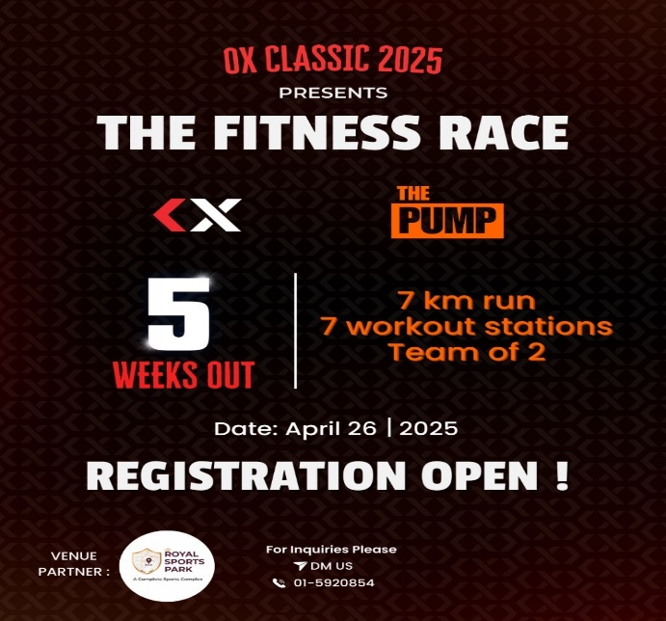

**Congratulations on your registration!**

Dear Participant,

We're thrilled to confirm your registration for the upcoming OX-Classic presents **THE** **Fitness Race**, **OX-Strength** in collaboration with **The PUMP**. Get ready for an exciting fitness challenge with your teammate.

**📅 EVENT DETAILS**

* **Date:** Saturday, 26th April 2025
* **Venue:** Royal Sports Park, Budhanilkantha
* **Link for the venue:** <https://g.co/kgs/bwbwdvf>
* **Format:** Partner Competition (2 people per team)

**🏃‍♂️ COMPETITION FORMAT**

* **Total Distance:** 7km run with 7 workout stations
* **Structure:** 1km run followed by 1 workout station (repeated 7 times with different workouts)
* **Partner Format:**
  + Partners run together for each 1km segment
  + Workout reps at each station will be shared between partners
  + Complete all 7 stations to finish the race

**⚠️ IMPORTANT NOTICE**

**At least ONE team member must attend the pre-competition briefing:**

* Date: Friday, 25th April 2025
* Purpose: Receive your team's exact **session time**, **team number** and **workout movement briefing.**
* Competition Structure: Teams will compete in **waves** of 10
  + First wave begins at **7:00 AM**
  + Subsequent wave will follow throughout the day

**🎒 WHAT TO BRING**

* Comfortable athletic clothing
* Outdoor running /training shoes
* Water bottle
* Towel
* Light snacks
* Any personal supplements
* Change of clothes
* Friends/Family/Relatives are welcomed

**📞 QUESTIONS?**

Contact our event coordinator at +977 9861858040

We look forward to seeing you and your partner demonstrate your fitness and determination!

**Team OX-Strength**

*Follow us on social media for event updates and training tips: @oxstrengthtrainingground*